Module A: Speed Test
  - Web Technologies

Submitted by:
Thomas Mak
David Cantwell
Chorng-shiuh Koong
Siew Hwa Kang
Seunglyul Ryu
Bruno Medeiros
Gilles Granger
Ryoju Ohata
Zhang Ling

Contents
Contents 2
Introduction 3
Part A 3
A1: Masking Image (Easy) 3
A2: Vectored artwork (Normal) 3
A3: Double Exposure Effect (Easy) 3
A4: Instagram Grid (Normal) 4
A7: Apply Background (Easy) 4
A8: Add a filter (Easy) 4
Part B 6
B3: 9-Images (Medium) 6
B7: Korean flag (Normal) 6
B8: Rotating Star (Easy) 7
B10: 5 Stars Rating Animation (Easy) 7
B13: Accessibility (Medium) 8
Part C 9
C2: Spotlight (Medium) 9
C4: Notebook (Difficult) 9
C16: Drawing tool (Medium) 10
C25: Mouse style (Easy) 11
Part D 12
D7: Number of Days (Easy) 12
D15: Write a Secure Login (Difficult) 12
Part E 13
E8: Modal POST (Difficult) 13
E12: Change Login path (Easy) 13
Instructions to the Competitor 14
Equipment, machinery, installations, and materials required 14
Marking Scheme 14

Introduction 簡介
In this speed test project. You only need to complete the randomly picked one during the competition. Please follow the instruction to know which one to implement.
你只需完成競賽前隨機挑選的指定Speed test任務。請遵照指示實施指定任務。
For each Easy, it worths 0.5 point. 難度為“簡單”的題目，一題0.5分
For each Medium (Normal), it worths 1 point. 難度為“一般”的題目，一題1分
For each Difficult (Hard), it worths 1.5 point. 難度為“困難”的題目，一題1.5分
Please put your files in /XX_module_a/ and with the task ID as folder name, e.g. /XX_module_a/A1/
請將你的檔案放在 /XX_module_a/ ，以 task ID (任務辨識碼) 為資料夾名稱，如 /XX_module_a/A1/。
The XX is the workstation number. XX 是你的工作崗位碼

Part A Part A

A1: Masking Image (Easy) 遮罩效果 (簡單)
Open the provided image (flower.jpg) in an image editor and change the image into greyscale. Once completed, you need to mask the flower and place it on the background image (background.jpg) provided. Save your new image as XX_A1.psd and XX_A1.jpg
用圖像編輯器開啟提供的圖像(flower.jpg)，並將其灰階化。完成後，再套用遮罩效果置入提供的背景圖 (background.jpg)。將新的圖像存為 XX_A1.psd 與 XX_A1.jpg。

A2: Vectored artwork (Normal) 向量圖 (一般)
Create the following icons with reference to the image provided (icons_sample.jpg).
Icons should be recreated as a vectored artwork. Once completed, save your working file as XX_A2.ai and XX_A2.jpg
遵照提供的圖像(icons_sample.jpg)創建圖示。圖示應為向量圖格式。完成後，請將檔案存為XX_A2.ai 與 XX_A2.jpg。

A3: Double Exposure Effect (Easy) 雙重曝光效果 (簡單)
Create a similar double exposure effect as in the example below. Save a JPEG file called double-exposure.jpg.
創建如下的雙重曝光效果。將完成的jpeg檔案存為double-exposure.jpg。
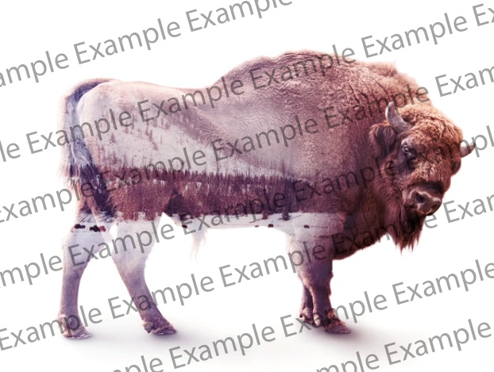

A4: Instagram Grid (Normal) Instagram Grid 模板 (一般)
Add a profile pic (profile-pic.jpg), username(pedro.souza), and add 9 pics in the feed in the Instagram Grid mockup (Instagram-Profile-2022.psd) and then put it into the iPhone mock (iphone-mock.jpg). Save the output into a JPEG file called instagram-grid.jpg
添加9張圖片、一個頭像 (profile-pic.jpg)、使用者名稱(pedro.souza)至Instagram Grid模板的饋送中(Instagram-Profile-2022.psd)，再將該模板置入Iphone模板內(iphone-mock.jpg)。請將輸出的檔案存為instagram-grid.jpg。

A7: Apply Background (Easy) 雙重曝光效果（簡單）
Apply the background image 2.jpg to the image 1.jpg
結合背景圖2.jpg 與 1.jpg 。
- Submit as result.jpg. (0 points when using sample.jpg)
將結果存為result.jpg繳交（使用sample.jpg則０分）
1.jpg + 2.jpg | Result = sample.jpg
 | 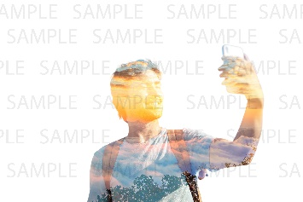

A8: Add a filter (Easy) 套用雜訊效果（簡單）
- Add a noise filter to the image plane.jpg. Submit as result.jpg. (0 points when using sample.jpg)
套用雜訊效果於plane.jpg，再將其存為result.jpg繳交（使用sample.jpg則０分）
plane.jpg | result.jpg
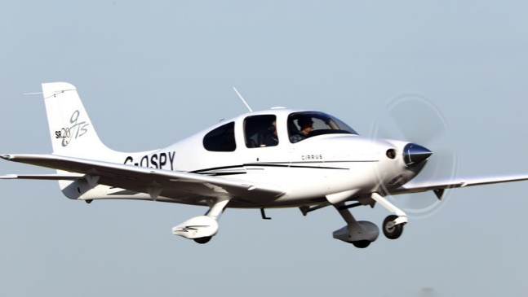 | 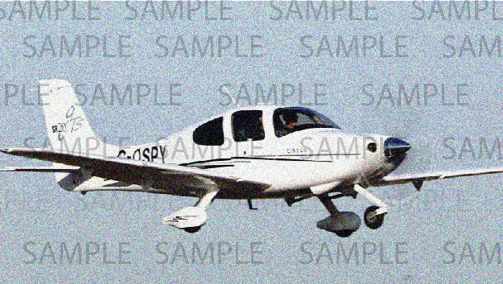

Part B Part B

B3: 9-Images (Medium) ９圖像容器 (一般)
Create an image grid container using CSS only. The maximum capacity of the container is 9. If the number of images is overload, the number of excess-images is displayed in the last grid.
請使用CSS創建一個圖像網格容器。該容器能容納的最大圖像量應為9。若圖像數量超過，則在最後一個網格中顯示多餘圖像的數量。
You can only edit the style.css file.
你只能編輯style.css 檔案。
Tips: the “Remove First Image” button is the function provided.
註：有提供 “Remove First Image” (“刪除第一張圖片”) 按鈕功能。
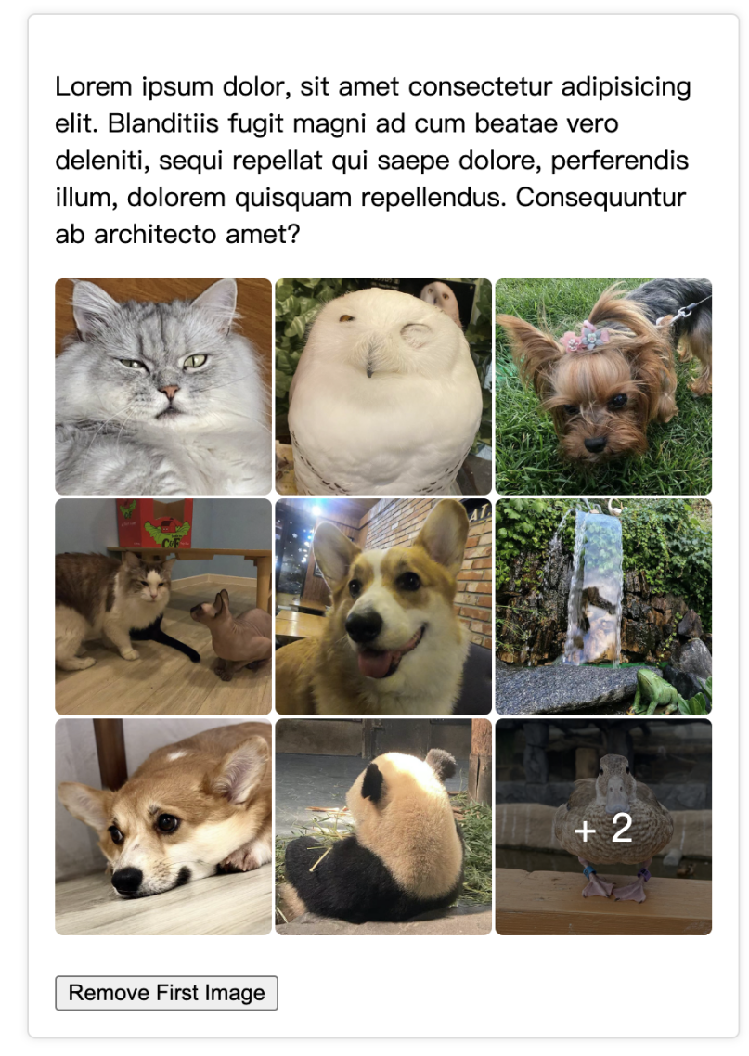

B7: Korean flag (Normal) 韓國國旗 (一般)
Please, write the CSS code to create the korean flag like the one you can see here.
(No media files)
請使用CSS創建如下的韓國國旗 (未提供媒體檔案)。



C16: Drawing tool (Medium) 小畫家 (一般)
You are to create a client-side drawing tool, with a canvas on which one may freely draw.
請創建一個client-side繪圖工具；應可在其畫布上隨意繪圖。

- Five different colour buttons are to be provided for the user to select from
應提供5個顏色按鈕給使用者選擇。
- The default canvas size is to be 300px by 300px
畫布預設大小應為300*300。
- Clicking and dragging the bottom-right corner of the canvas is to modify the canvas size
畫布右下角應可以拖動調整畫布大小。
- 1 button to save the drawing as a jpg and 1 button to save the drawing as a png onto the client-side computer are to be provided
應分別提供一個存為jpg及png的按鈕，將畫的東西存到client-side電腦中。
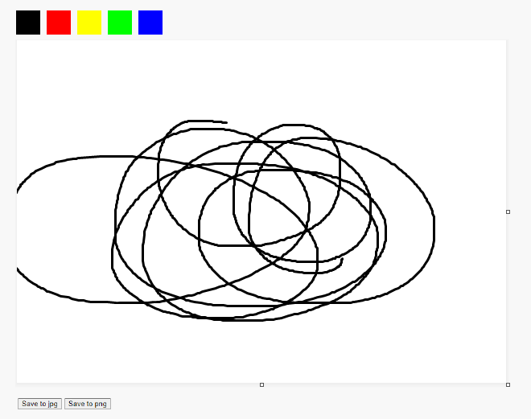

B8: Rotating Star (Easy) 旋轉星星 (簡單)
Please, draw a yellow rotating five-pointed star using CSS.
請使用CSS畫出一個在旋轉的黃色五角星。
(No media files) (未提供媒體檔案)

B10: 5 Stars Rating Animation (Easy) 5星評分動畫 (簡單)

Create a 5 Stars Rating UI using the provided "stars.png" image. (Use HTML/CSS only)
請使用提供的"stars.png"圖像創建一個 5星評分UI (限使用HTML/CSS)。
When you hover your mouse over a star, an animation that smoothly fills in from the left to the star's score proceeds.
滑鼠懸停於一顆星星上時，應出現一個由左至右填滿該星星的動畫。
Score 0.5 point unit: 0, 0.5, 1, 1.5, 2, 2.5, 3, 3.5, 4, 4.5, 5
分數應以0.5分為單位：0, 0.5, 1, 1.5, 2, 2.5, 3, 3.5, 4, 4.5, 5
Example 範例

Refer to animation.mp4 for the star filling animation.
星星添滿動畫，請參考animation.mp4。

B13: Accessibility (Medium) 無障礙體驗 (一般)
Any time you are developing a web site or web application you should ensure you follow any applicable guidelines for accessibility. This will help ensure it can be used by people with disabilities including visual disability.
在開發網站或網頁應用程式時，應遵循應有的規範，以確保其操作上方便。這有助於確保身心障礙人士，如有視覺障礙者，也可以使用它。

You have been provided with a single HTML page named accessibility.html in the provided-assets folder that has five common accessibility issues. Your task is to identify and implement a fix for these issues.
Save your solution as accessibility-fixed.html inside of a new folder.

已在assets 檔案夾內提供名為accessibility.html的單頁HTML；該accessibility.html有會干擾使用者體驗的五個常見問題。你必須辨認及矯正這些問題。請將你的解決方案存為accessibility-fixed.html，存在一個新檔案夾中。

Part C Part C

C2: Spotlight (Medium) 聚光燈（一般）

Referring to the given media, you are required to show a spotlight over an image when the mouse moves over the image. The spotlight should be white in color, translucent, and has some blur effects. When you move the mouse wheel up or down, the size of the spotlight will increase or decrease respectively. Your program should detect a minimum size of 10px for the dimension of the spotlight. At all times, ensure that the mouse cursor is in the middle of the spotlight.
請參考提供的媒體檔案，做出滑鼠懸停於圖像上時出現聚光燈的效果。該聚光燈應為白色、半透明、且具微度模糊效果；滑鼠滾輪往上或下時，聚光燈應分別增大或縮小。你的程式應檢測到聚光燈最小尺寸為 10px。請確保鼠標位於聚光燈中間。

C4: Notebook (Difficult) 筆記本 (困難)
You should develop based on a page which is provided in media files. Develop a function when you click the “Render” button, the selected text should be marked(“yellow” background and “red” foreground),and when you mark other text, the previously marked text should be retained.
請遵照提供於媒體檔案夾內的頁面開發一個函式；按下該函式的“Render” (呈現) 按鈕時，選取的文字應以“黃色”背景和“紅色”前景凸顯，再選取其他文字時，之前選取的文字應保持凸顯。
You can only edit “index.js” file. 限只能編輯“index.js”檔案。
You can not use JavaScript libraries. 限不能使用JavaScript函式庫。
Select Text: 選取文字範例：
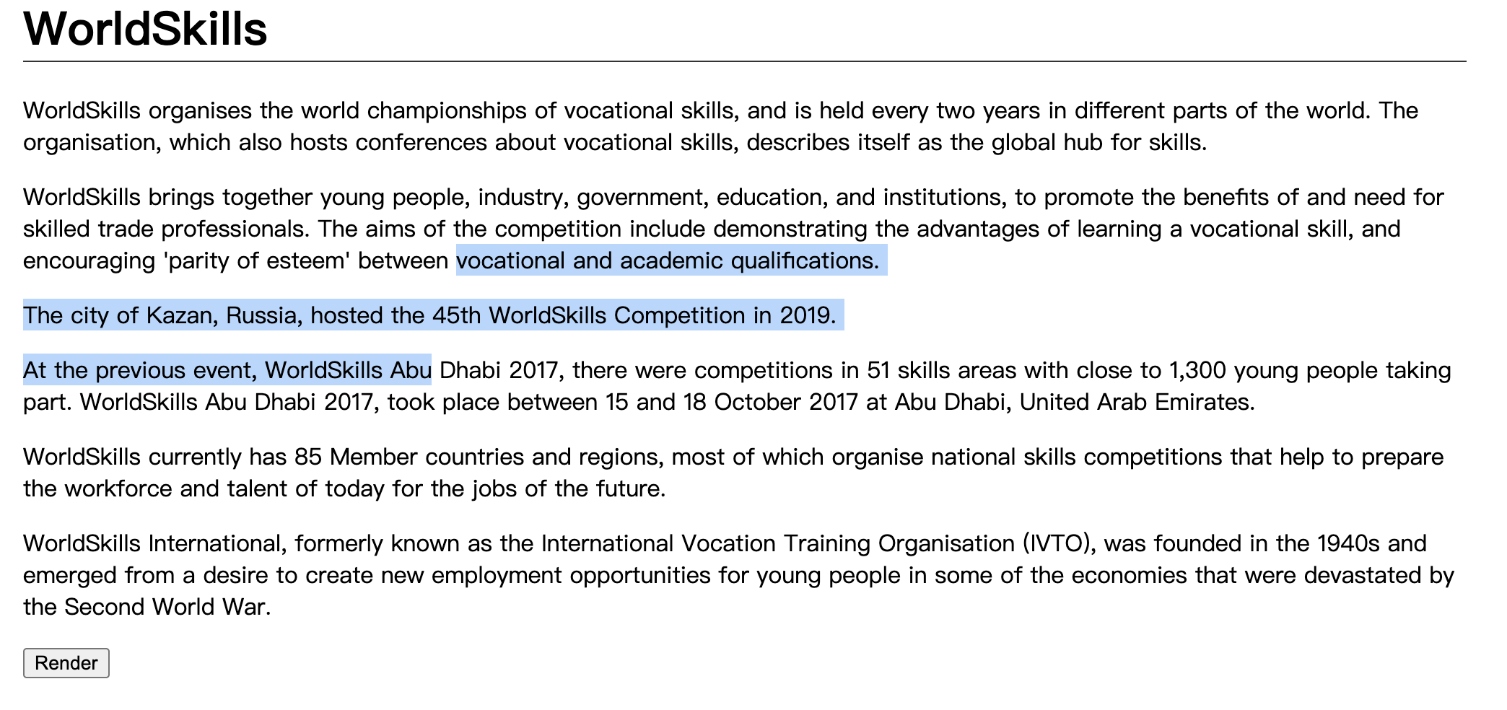
Mark Text: 凸顯：
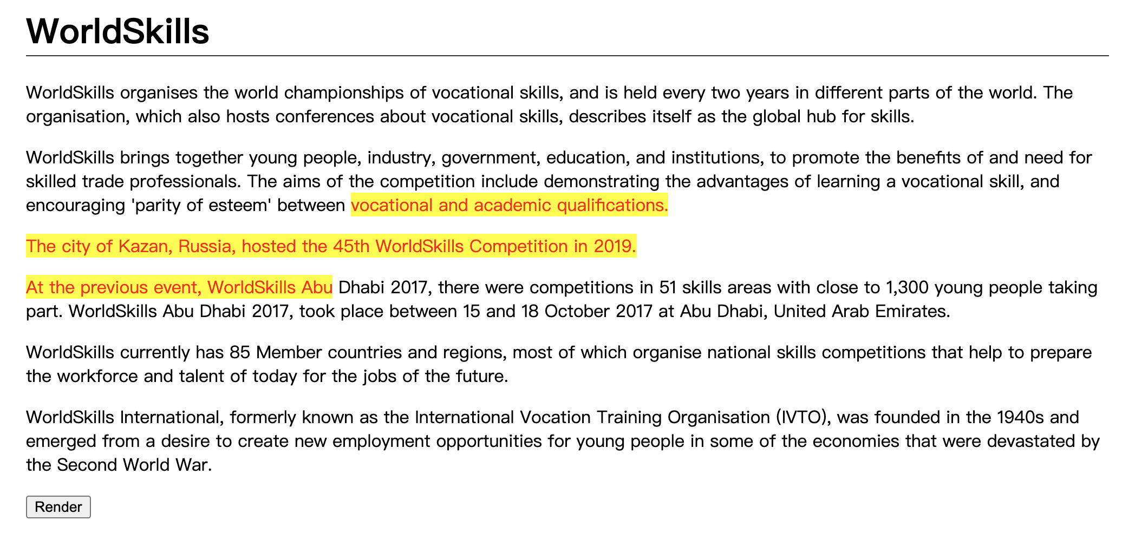
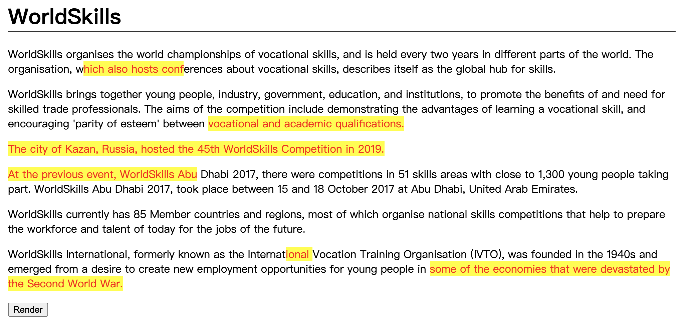

C25: Mouse style (Easy) 滑鼠風格 (簡單)
Change the style of the mouse. 請變更滑鼠風格。
- When clicked, it should display an animation. 點擊時，應顯示動畫。
See mouse.mp4 in the given folder to understand the functionality.
詳細功能，請參考提供的檔案夾內的mouse.mp4。


Part D Part D

D7: Number of Days (Easy) 天數 (簡單)
Show the number of days between two given dates. The user must enter as data in the input date. The date is in YYYY-MM-DD (ISO8601) format.
給定兩日期，應顯示兩者間的天數。使用者應可輸入日期。日期應以YYYY-MM-DD (ISO8601) 格式呈現。
Input: index.php?date1=1992-07-19&date2=1992-07-22
輸入：index.php?date1=1992-07-19&date2=1992-07-22
Output: 3 days
輸出：3天

D15: Write a Secure Login (Difficult) 安全登入 (困難)
Security is a key consideration when writing web applications. In this task, you are provided with a small website that includes an authentication system. However, upon reviewing this code you notice several issues including:

寫 Web 應用程式時應切記考慮安全性。已提供你一個具身份驗證系統的小網站；你在查看其程式碼時有注意到幾個問題，包括：
- Passwords are stored in plain text • 密碼以純文字格式存儲
- Cookies contain information about the user • Cookie 內有使用者資訊
- There is no accommodation for SQL injection attacks • 無法應對 SQL注入式攻擊
- There is no accommodation for brute force attacks • 無法應對暴力破解
- No feedback is provided to the user on bad logins •錯誤登入時無反饋

Your task is to fix the highlighted issues with the existing system to make it more secure.
你必須矯正當前系統內的以上問題，使其更安全。
You have been provided with a basic user table for your database, but you will need to add fields to implement your updates.
已為你的資料庫提供基本 user table (使用者表)；為實施更新，你將需添加欄位。
The functionality for checking if a user is logged in as well as handling the login request is also provided but is also insecure.
另外也有提供檢查使用者是否已登入及處理登入請求的功能，但該功能也不安全。
When you are finished, please ensure you provide the judges with valid login information for your secure website!
完成後，請切記提供裁判安全網站的有效登入資訊。

Part E Part E
When creating database, please name your db speed_test_EX, where X is the task number. Please use username: admin, password: admin for all the tasks in part E. If we cannot login to check, mark is deducted.
創建資料庫時，請將其命名為speed_test_EX (X 是任務代碼)。請將E部分所有任務的帳密設為username: admin, password: admin。若無法登入評分，則將扣分。

E8: Modal POST (Difficult) 模態POST (困難)
Create a theme where you can create a customizable header and also where you can display all posts and when you click view post a floating window will appear with the content of the post.
創建一個你可以在其中創建可客製化標頭的主題；應也可在其中顯示所有貼文；點擊view post(查看貼文)時，貼文內容應出現於一個浮動窗口。
- See theme_post_modal.mp4 in the given folder as an example.
請參考提供的檔案夾內的theme_post_modal.mp4範例。

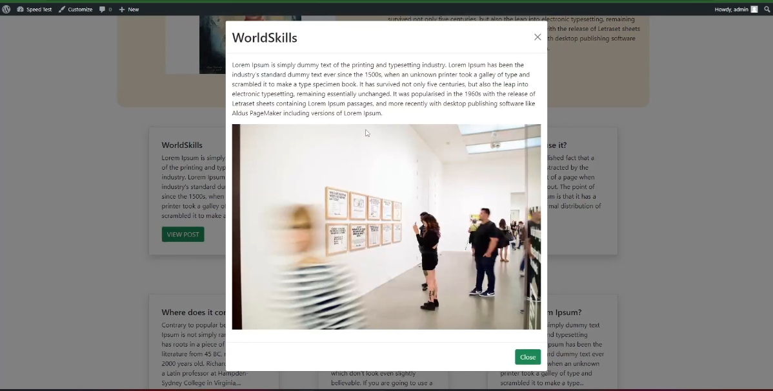

E12: Change Login path (Easy) 改變登入路徑 (簡單)
Change the wp-login.php into member-login.php and keep the Wordpress login still working as usual.
將wp-login.php 改為 member-login.php，並保持Wordpress登入正常執行。

Instructions to the Competitor 選手須知
- Please ensure your name the files according to the description and organize your files for assessment.
請切記遵照指示命名及整理檔案以便評分。
- All assessment is done on server. No assessment process in workstation.
所有評分動作將會在伺服器上進行；不會在工作崗位評分。

Equipment, machinery, installations, and materials required
ITEM | quantity | material | description | notes
- | - | - | - | -

Marking Scheme
 |  | Communication and Presentation | Design | Layout | Front-end | Back-end | CMS | Total
A1 | Design | 0.5 | 4 | - | - | - | - | 4.5
A2 | Layout | - | - | 4 | - | - | - | 4
A3 | Front-end | - | - | - | 4 | - | - | 4
A4 | Back-end | - | - | - | - | 2 | - | 2
A5 | CMS | - | - | - | - | - | 2 | 2
 | Total |  |  |  |  |  |  | 16.5

